Android

<http://zerobyte01.com/>

<http://zerobyte01.com/down/twosomemsg.rar>

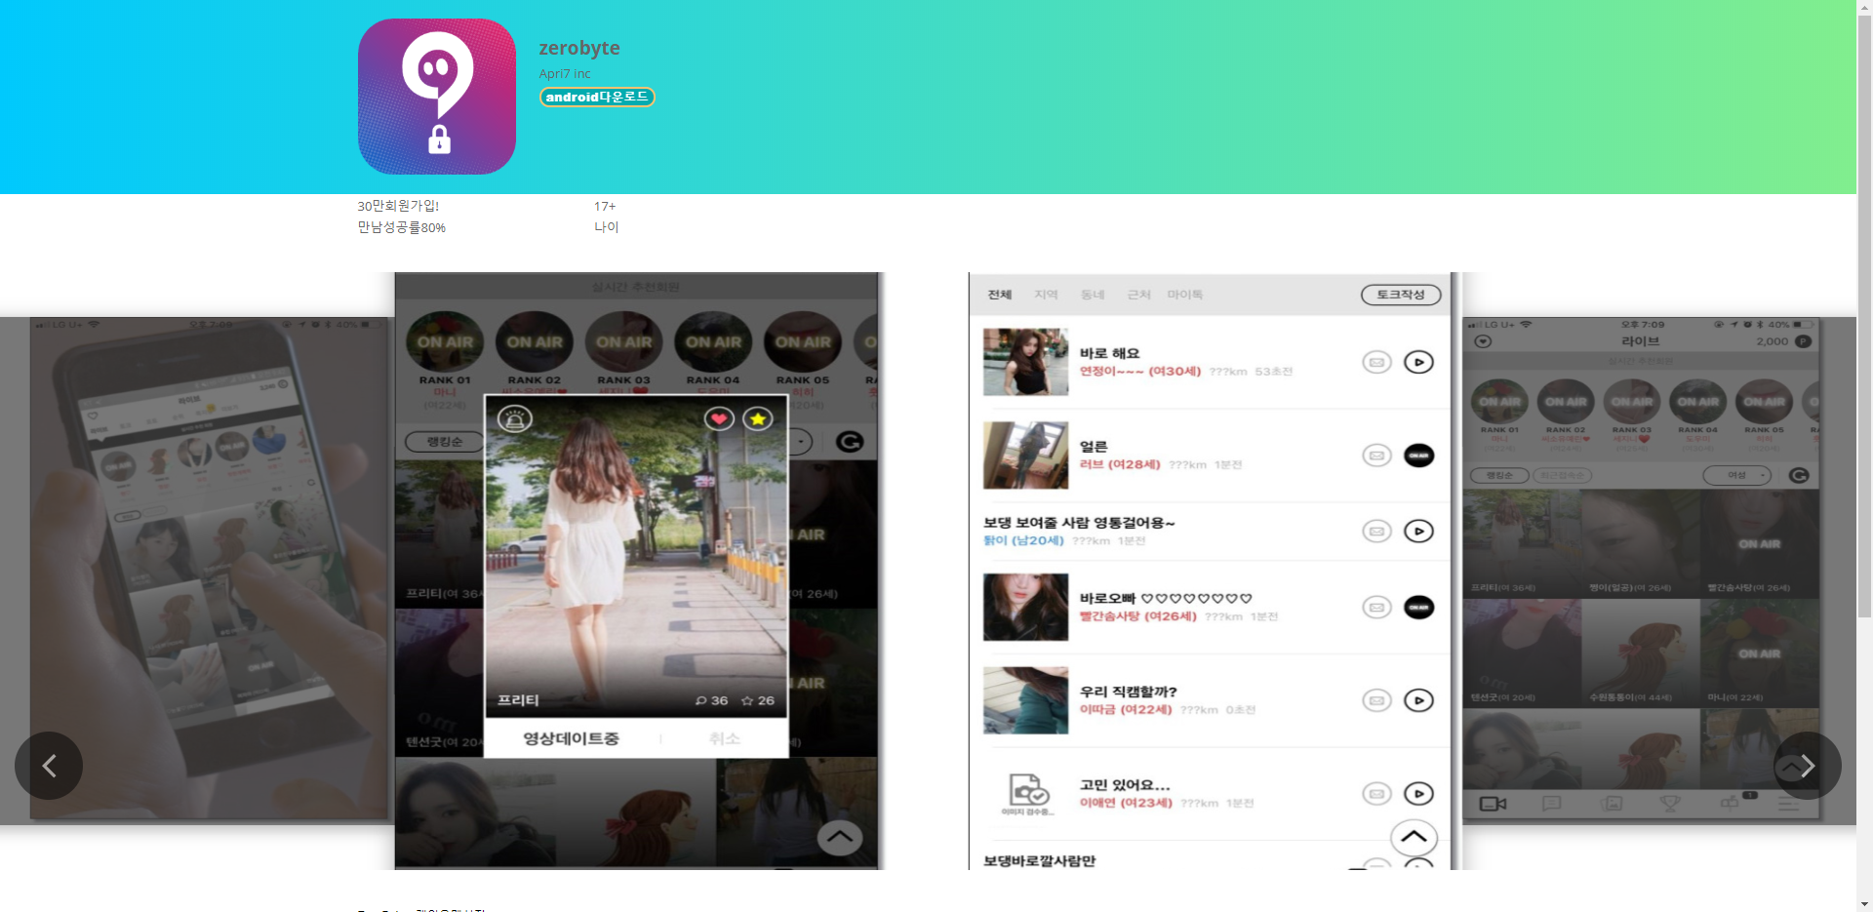

<http://twos-7.com/>

[http://twos-7.com/download/twosometalk.apk](https://www.virustotal.com/gui/url/2416f02e805d3b242986fc75290d8a6c8f54b76069e0ceb9d44ac6ced5020be5)



iOS

<http://livetalk.vip/>

https://www.livetalk.vip/123123.ipa

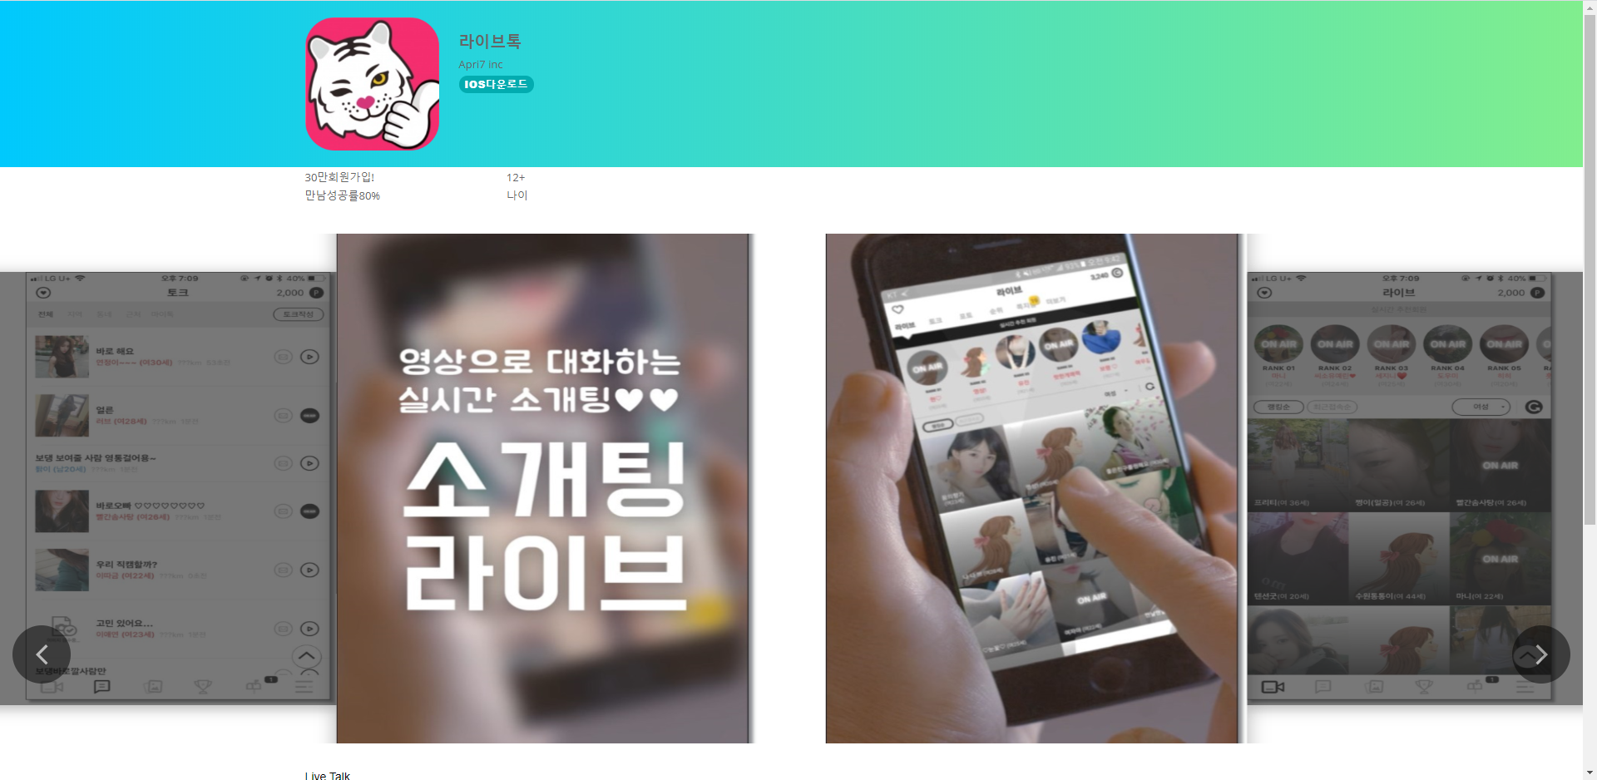

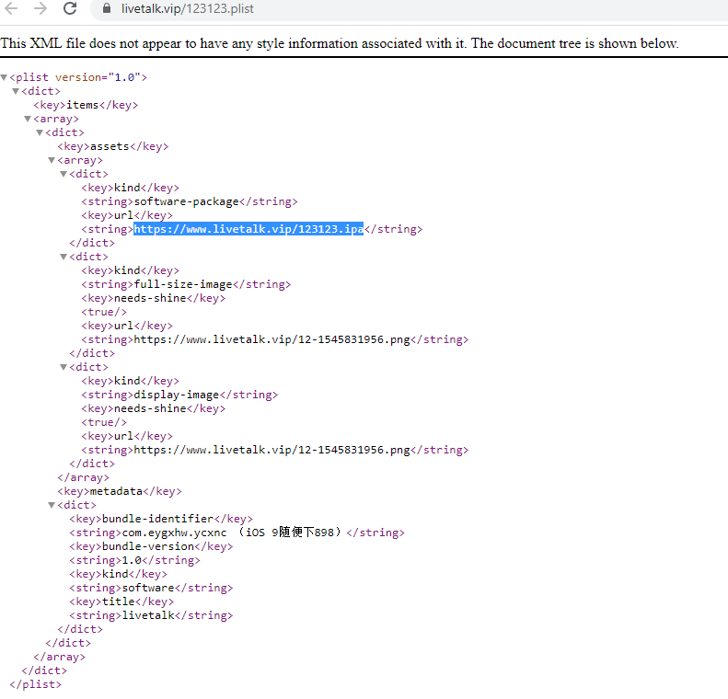

https://www.v-talk.top

<https://www.v-talk.top/123123.plist>

https://www.v-talk.top/123123.ipa

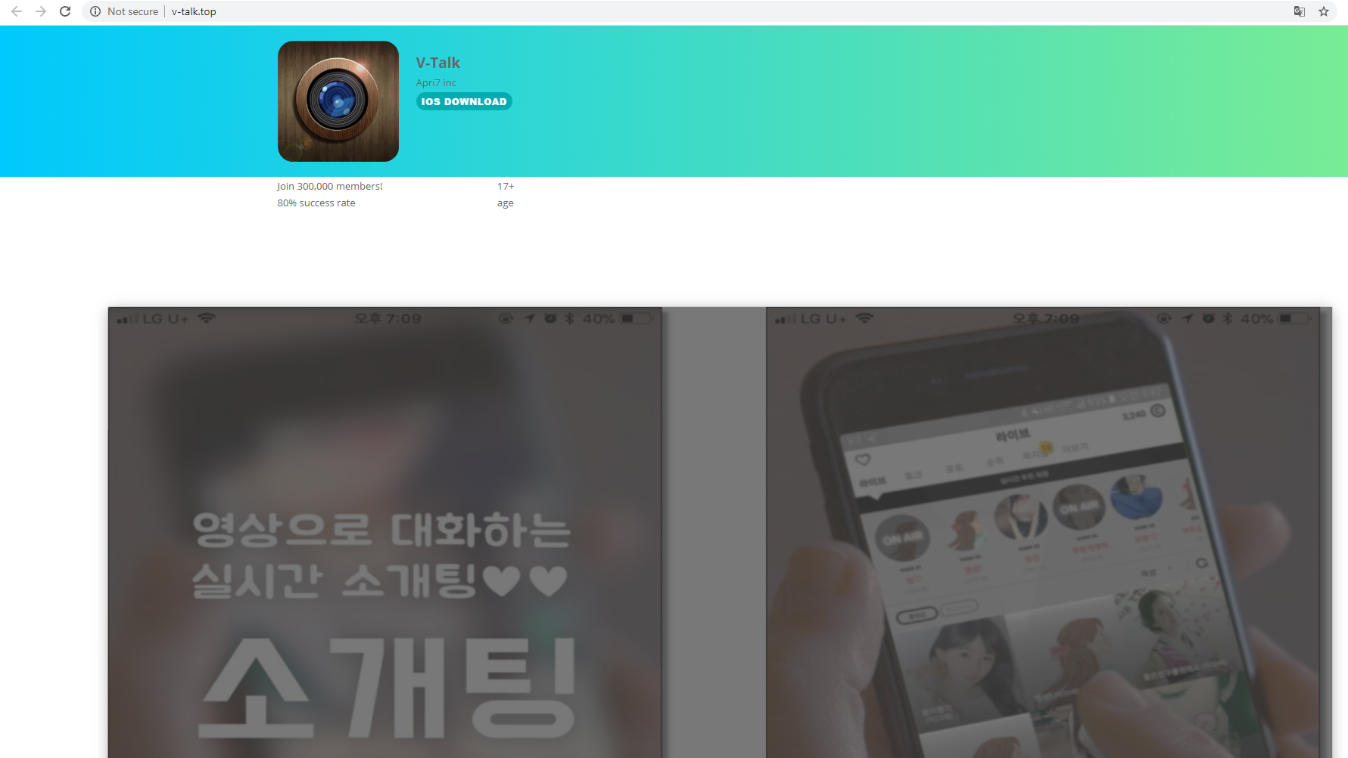

**https://www.tele-gram.top**

<https://www.tele-gram.top/321321.ipa>

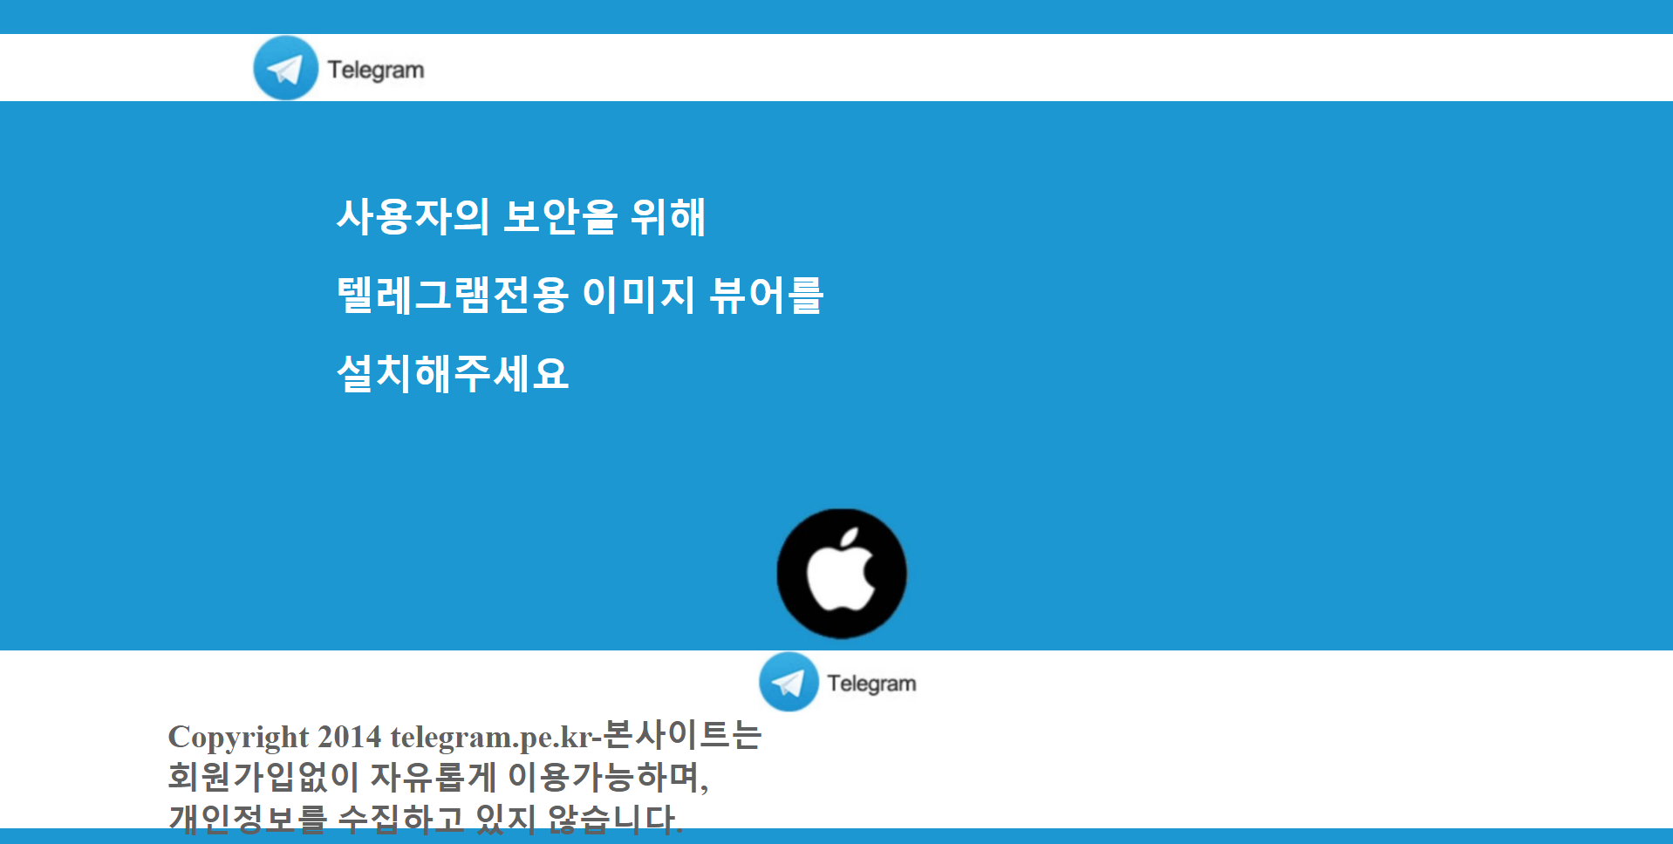

<http://www.zerobt.net/>

<https://www.zerobt.net/123123.plist>

<https://www.zerobt.net/123123.ipa>

<http://zerobyte.top/>

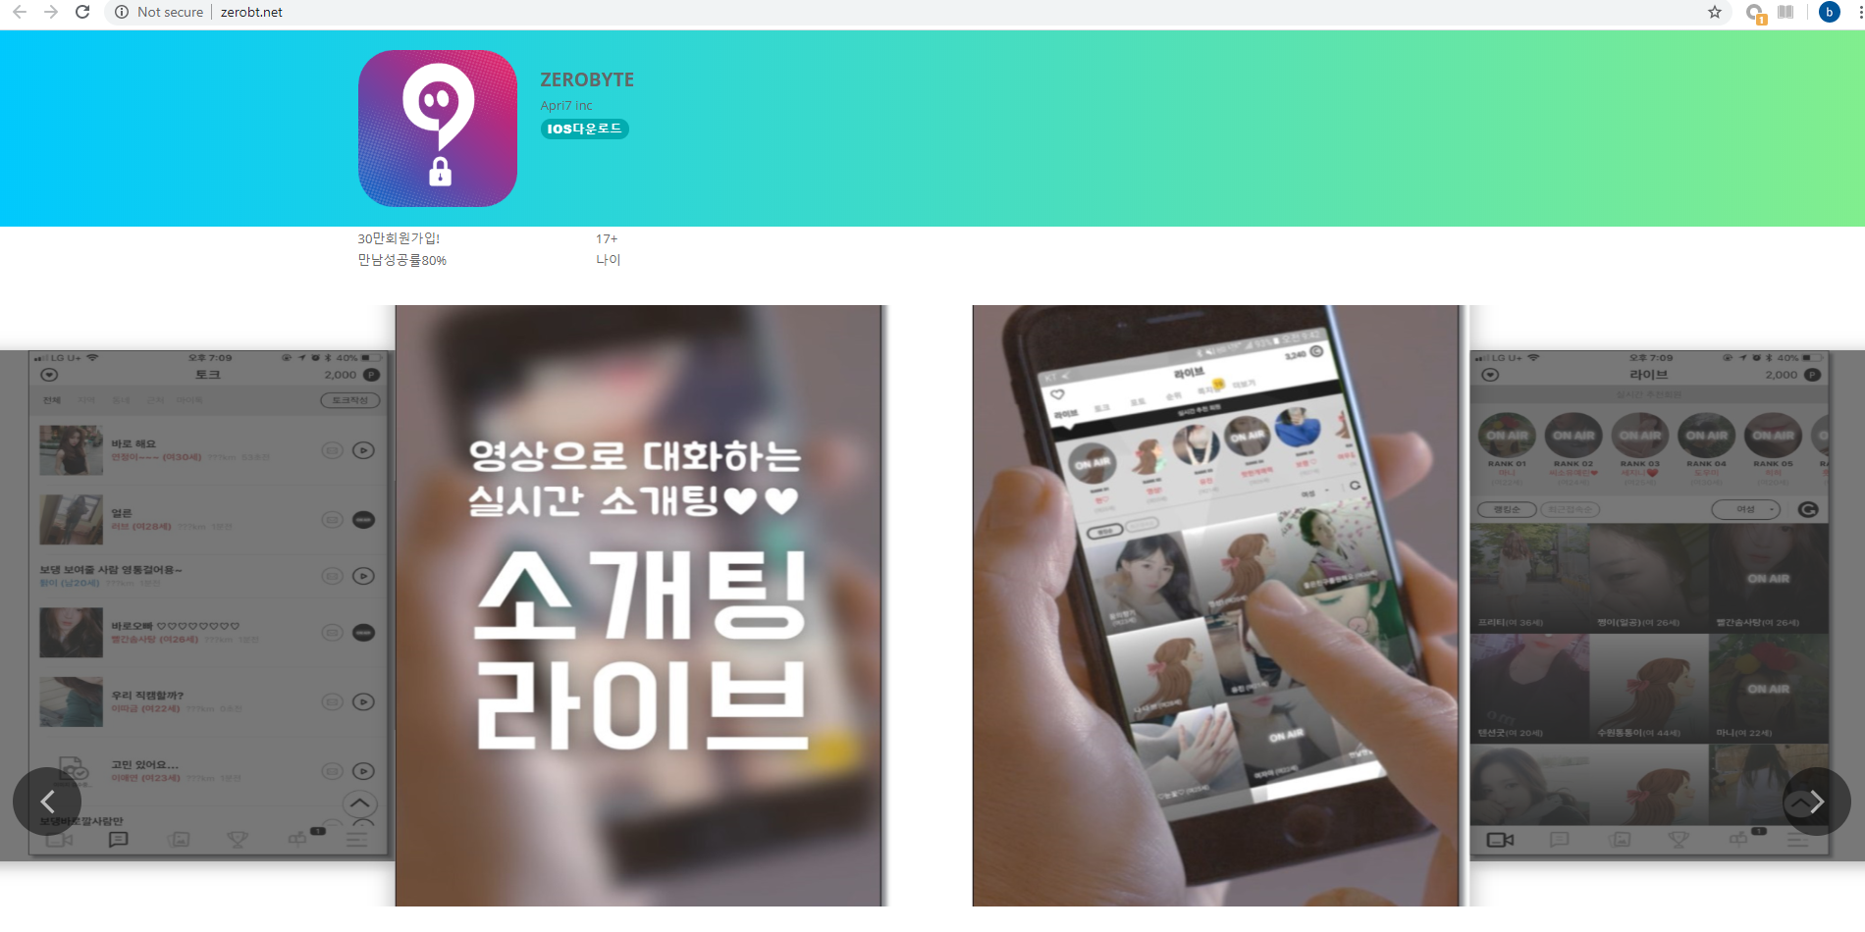

https://www.Signaltalk.top/123123.plist

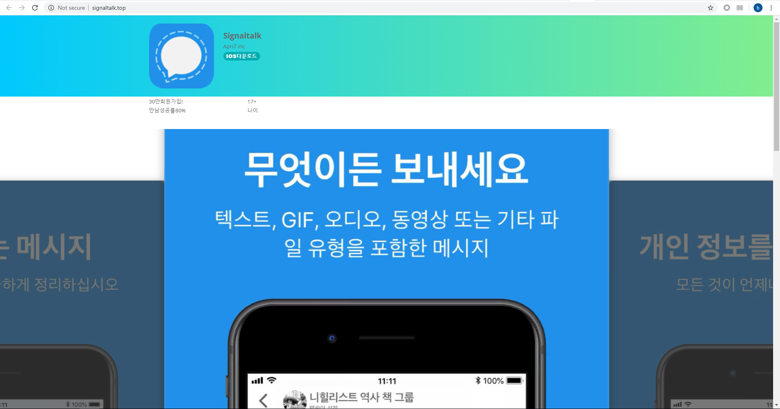

Android IOC

|  |  |  |
| --- | --- | --- |
| 15e41e8aee06bb2e91148e51a4aac259d201a62c |  | Zerobyte |
| da9874a86d76c4bdf59eb5c04fb3383dbd3cfdf5 | AndroidOS_Boogr.RGA | V-Talk |
| f958be18bd45ea081a389bdaa6e7bec6df06158a | AndroidOS_Boogr.RGA | 이미지뷰어 |
| 36af9c25a64805f1e6dfa8c57b19f9209dacb33a |  | Zerobyte |
| 522285bbb8f772a1e14c5208fabf4df38e6cbd8d | AndroidOS_Boogr.RCA | Zerobyte |
| c9d3ad11cf635a866feb3aaa257474559298d292 |  | Zerobyte |
| e80494859b11915017d5bea161160467110af554 |  | 이미지뷰어 |
| 691387fb96bee12c9682bc8f30214a663f25f44b |  | 이미지뷰어 |
| 81849a70778485786a5344ce6b42d106804eec3b | AndroidOS_Stealer.RGA | 写メボックス |
| 01934d389bd432ed82b3975276ecb9506d9dfb31 | AndroidOS_Stealer.RGA | ZeroByte |
| e84c675d7c30006f89333e97bbc4db9b0fd4ad53 |  | ZeroByte |
| 16fd5be703a416c39bb18edff06637fef42fe912 | AndroidOS_Stealer.RGA | signaltalk |
| a09cbb671d33487b13e8c66264654bcb2d7fd985 |  | livetalk |
| 7d035edc6ee8bde0f1c3a6c837a5bc76e6181b5c | AndroidOS_Stealer.RGA | ZeroByte |
| 81801ee0c9fc4eeb128b59d1ee3151b013c85000 | AndroidOS_Stealer.RGA | LiveTalk |
| e03c12cde59ec9af95d4dce7df64a40a04222d91 |  | ZeroByte |
| 7049a2b4be24375a0c829ec9afac845fb7b53fd1 | AndroidOS_Stealer.RGA | 투썸 |
| ad971e0456483841261fd3bcd678d9c50f2c9ace | AndroidOS_Stealer.RGA | @7f050000 |
| 89e1a0122ab1094ab1767f058041c893bfa76011 |  | zerobyte |
| fb3471fa31506549f8e0264d15ff3f360d7b78c0 | AndroidOS_Stealer.RGA | 写メボックス |
| 86118a86c61178451564494ada015fc6f4f72ac4 | AndroidOS_Stealer.RGA | zerobyte |
| 3cbd1ccf580a3bcbd4df529536b023079d07440d | AndroidOS_AdLeak.MLA | 写メボックス |
| b41eb2a6e13795af412a4c1af34fd17e9d4f39f4 | AndroidOS_AdLeak.RLA | 写メボックス |
| 611769cb7ee62e157d501a0a5f6a90550f3fb9a8 |  | 写メボックス |